Ideation Phase
Brainstorm & Idea Prioritization Template

Date | 16 Feb 2026
Team ID | LTVIP2026TMIDS81358
Project Name | OrderOnTheGo : Your On-Demand Food Ordering Solution
Maximum Marks | 4 Marks

Step-1: Team Gathering, Collaboration and Select the Problem Statement
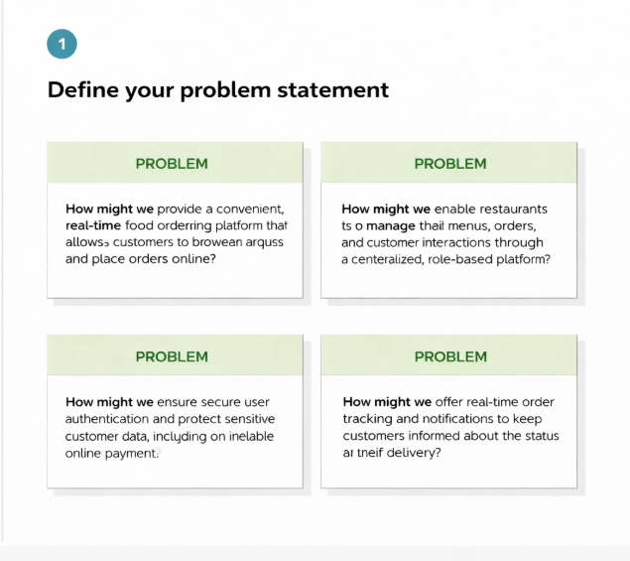
Step-2: Brainstorm, Idea Listing and Grouping
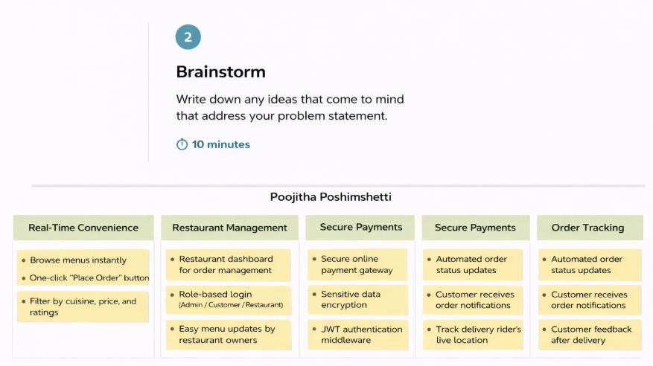
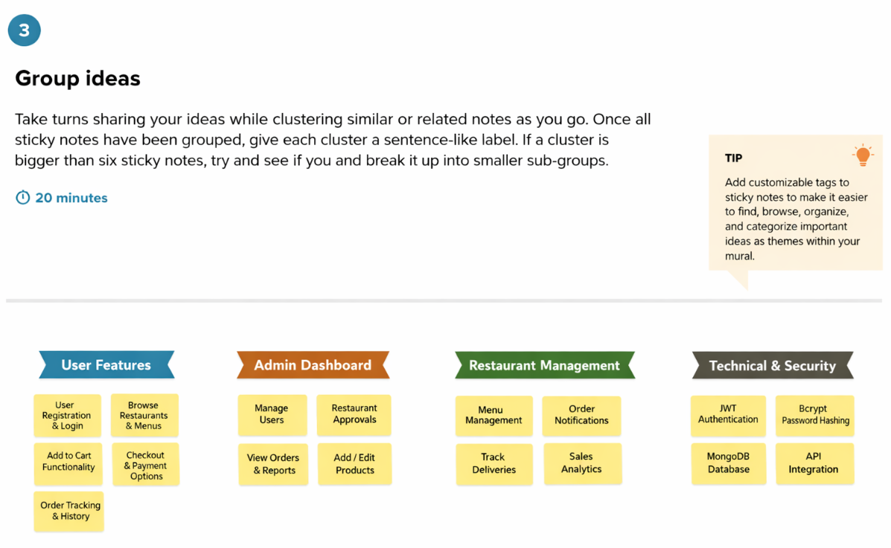
Step-3: Idea Prioritization
